Worksheet 5:  Website news clips | 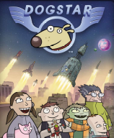

Student name:________________________________________________

Teacher:________________________________Class:_____________________

INSERT STILL IMAGE FROM WEBSITE:  TOP LEFT HAND USI NEWS CLIP | Clip 3: Inventor of the Robog
 | What is the clip about?
 | Who is the interviewer?
 | Who is interviewed?
 | What do you find out in the interview?
 | What do you find out about Hank?
 | What do you find out about Bob Santino?
INSERT STILL IMAGE FROM WEBSITE:  TOP RIGHT HAND USI NEWS CLIP | Clip 4: Who created the Robog?
 | Who is the interviewer?
 | Who is interviewed?
 | What do you find out in the interview?
 | What do you find out about Hank?
 | What do you find out about Bob Santino?
 | What is the clip about?

